C207 Database Systems
ESE Assignment Question

Notice on SOI’s Academic Dishonesty and Plagiarism:
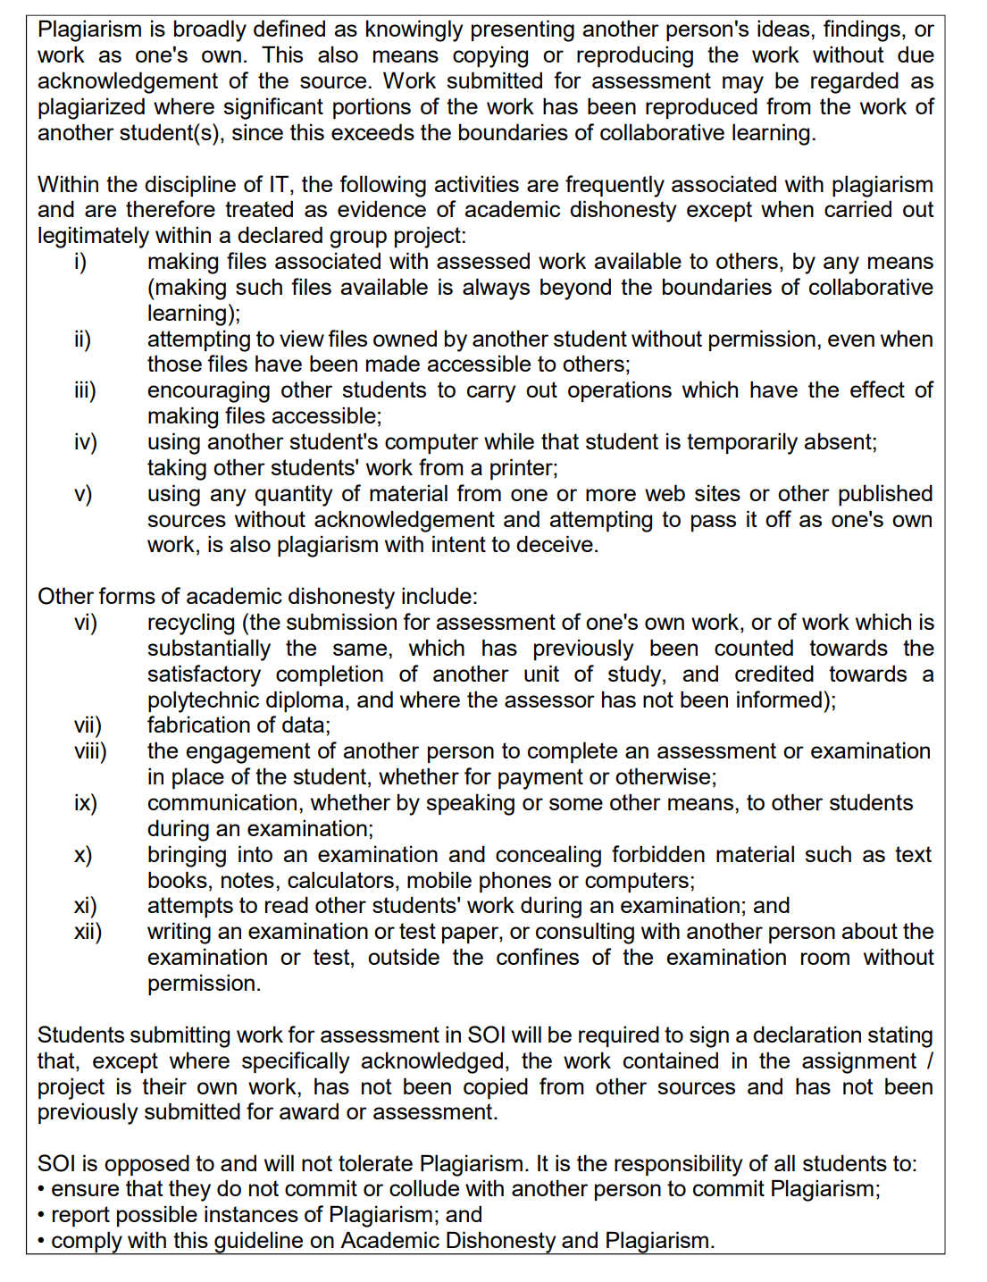
- Raffles Airways is a global airline, flying passengers to where they need to be for more than 100 years.
- Design the schema diagram for a flight reservation application based on the sample user interfaces and processes for
  - Purchasing flight tickets (Annex A). This involves:
    - Entering dates, arrival and departure airports of flights.
    - Choosing the flight.
    - Checking flight details and confirming the price.
    - Entering passenger details.
    - Entering payment details with optional seat selection purchase.
    - Confirming booking.
  - Check-in to flights (Annex B) ² which involves
    - Entering a booking reference number.
    - Viewing and selecting passenger checking in under the same booking reference.
    - Entering passport information.
    - Confirming seats
    - Checking in baggage.
    - Printing or emailing boarding passes.
- Your ERD design must take into account the following requirements:
  - The person booking the tickets must be one of the passengers travelling. If he/she logs in, then his/her personal details are automatically populated in the passenger details. No password is stored in the system.
  - There are different types of seat classes available for passengers to chose from. Example: first, business , premium economy and economy class.
  - The baggage weight allowance a passenger is allowed on the flight is dependent on his/her seat class.
  - The price of each flight ticket is the sum of the base ticket price for the flight and the seat charge. The seat charge is based on the premium rate for each class. The premium rate is different for each class but the premium rate is the same regardless of destination.
  - Once payment has been successfully processed, a booking number would be issued and a ticket would be issued for each reserved flight within the booking. The details of the booking and all its reserved flights, would be sent to the customer’s stated email.
  - Before any flight can be scheduled, the airline must receive permission from the relevant airport authorities. The permit number of the flight is kept in the database for easy access.
  - Passengers can use vouchers issued by Raffles Airways to offset the cost of their travel. Multiple booking vouchers can be used in a single booking but each voucher can be used once only regardless of whether the full value of the voucher is used or not. The vouchers are issued when Raffles Airways or the passenger is unable to fly under special circumstances, or when a passenger redeems his/her travel points. Voucher issuing and travel points tracking are not features in this system.
  - Raffles Airways is a member of the Cosmos Alliance where it participates in “code sharing” arrangements with member airlines. For example, Raffles Airlines and Down Under Airlines, both market and publish the Sydney to London flight with Down Under Airways operating the first leg of the flight between Sydney to Singapore and Raffles Airways operates the Singapore to London leg of the flight.
  - Air-crew are assigned to flights that either originate or terminate at the airport they are based in. The role a staff undertakes may differ for each scheduled flight. For example, a staff may be the flight captain on a short flight but may be the second pilot on a flight that is longer in distance.
  - Payment details are not captured in this system.

Yellow arrows are the naviation arrows in the images

User Interfaces adapted from British Airways Return Flights Booking
ANNEX A: PURCHASE FLIGHT TICKETS

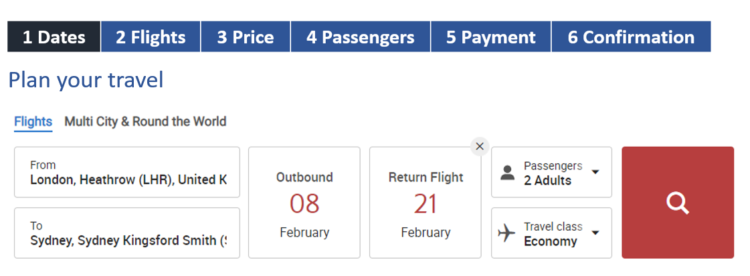

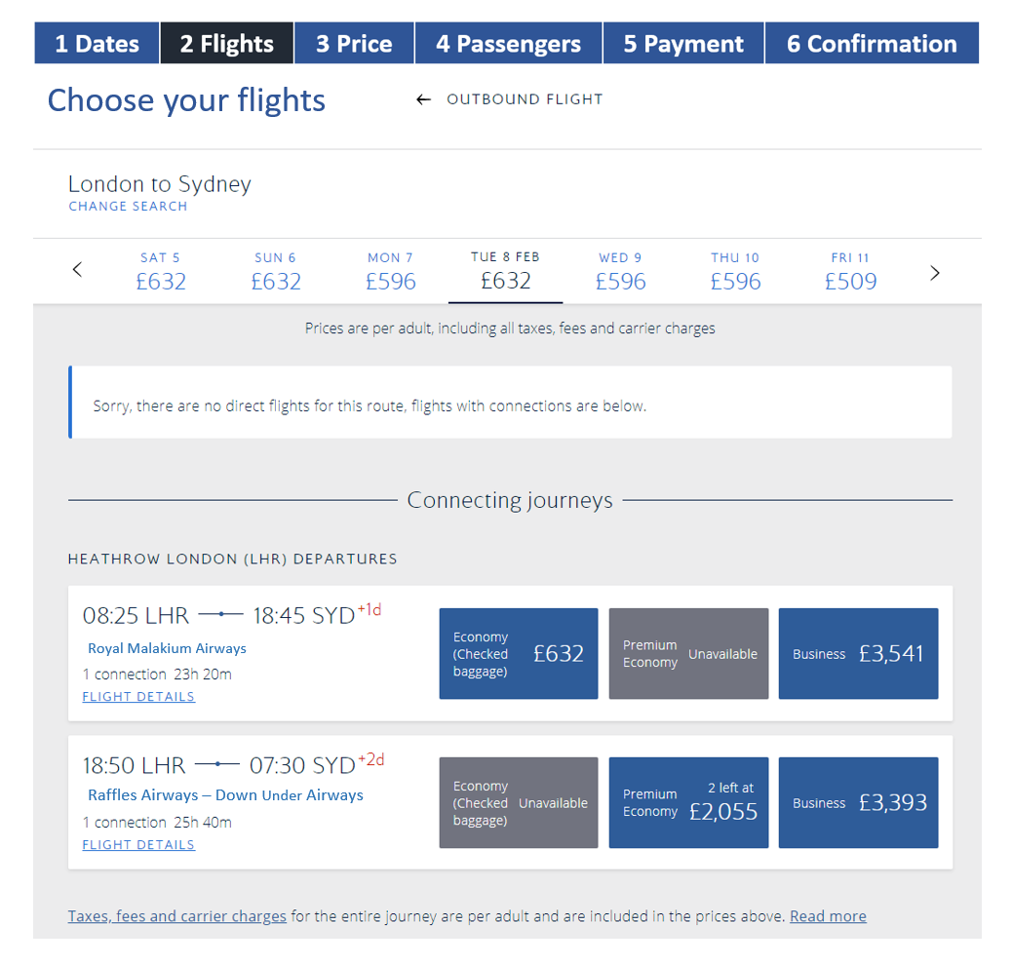

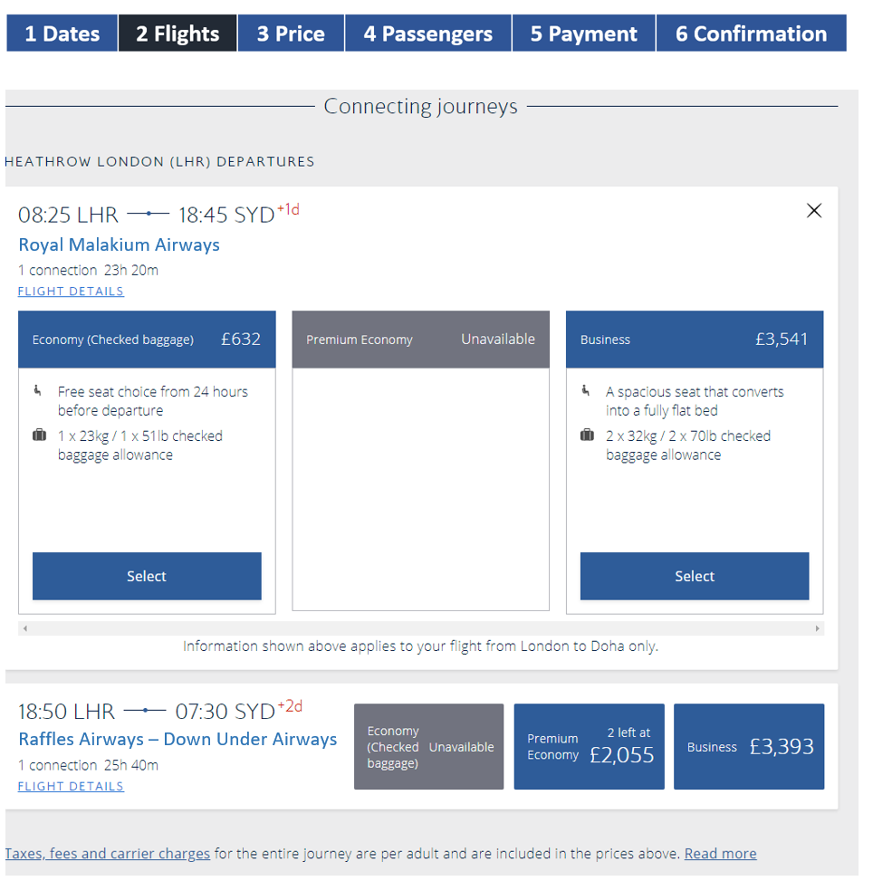
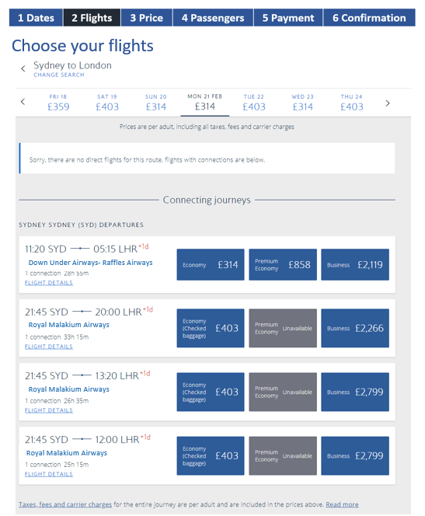
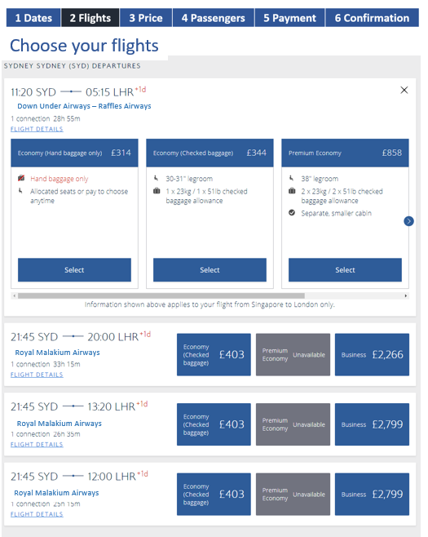

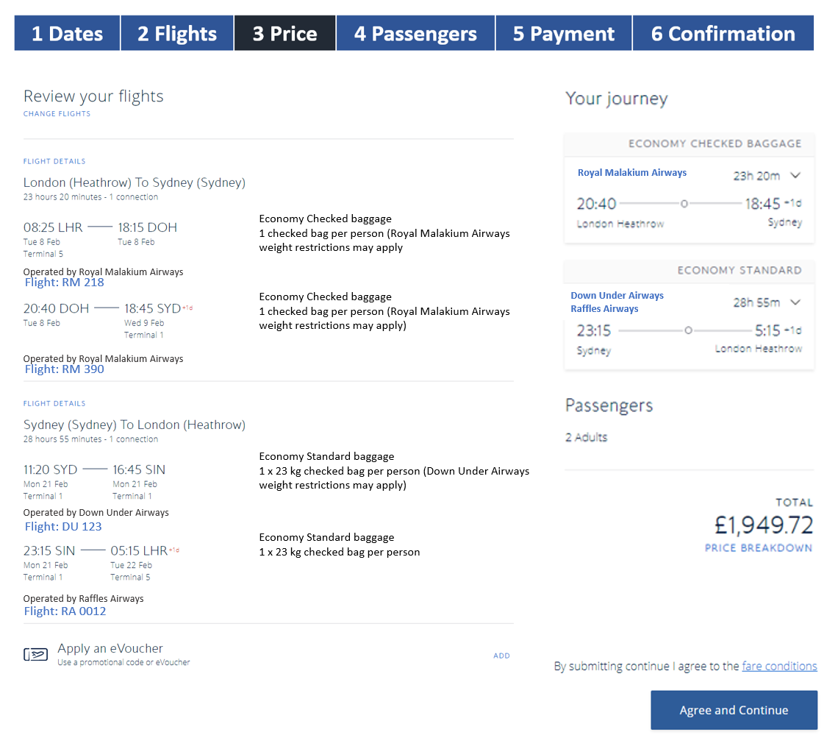
Enter voucher details if selected.

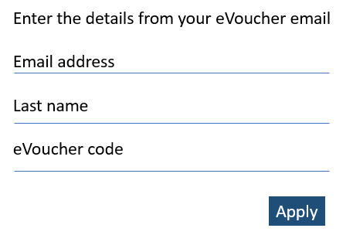

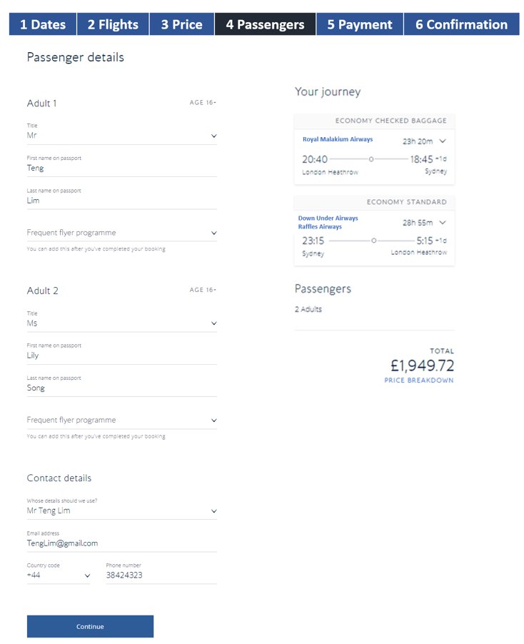

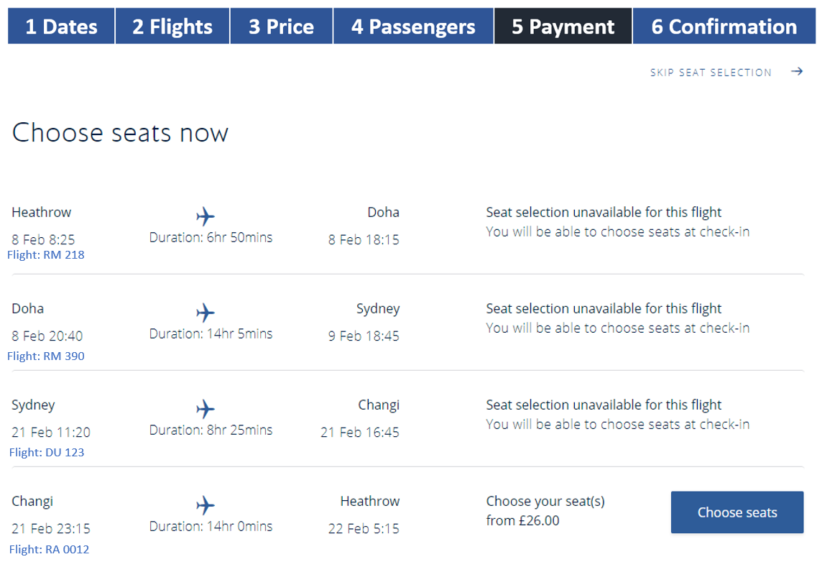
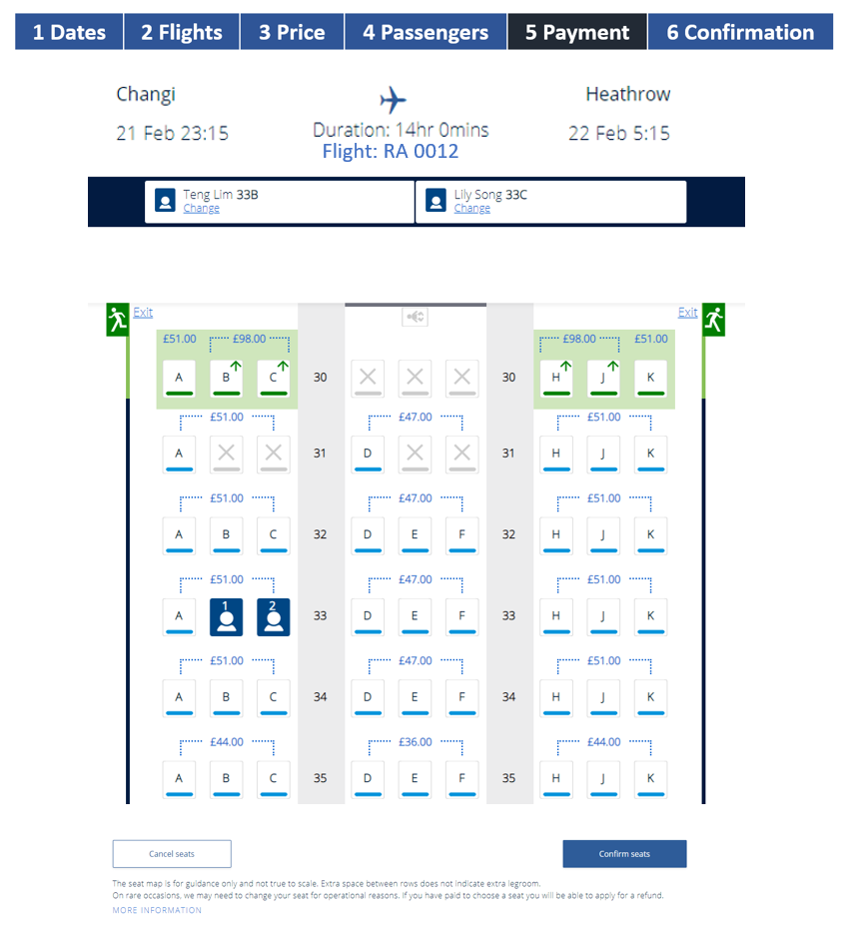

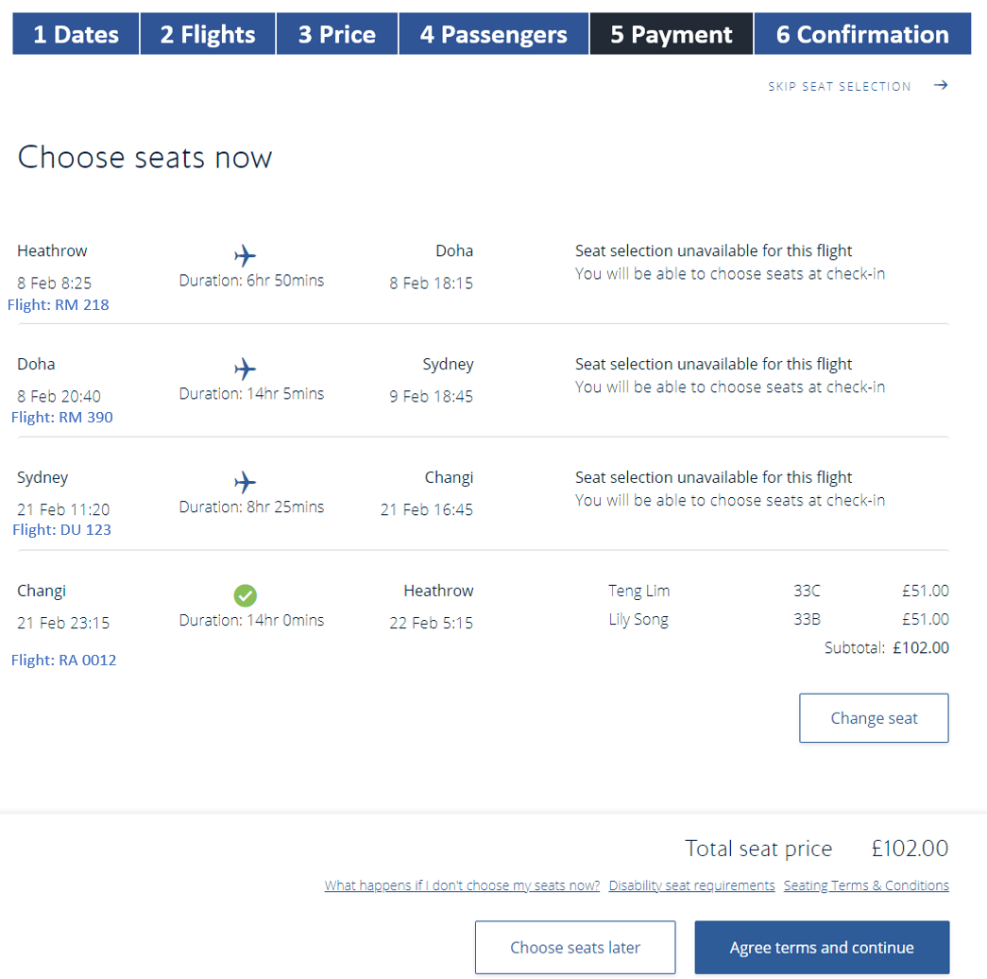

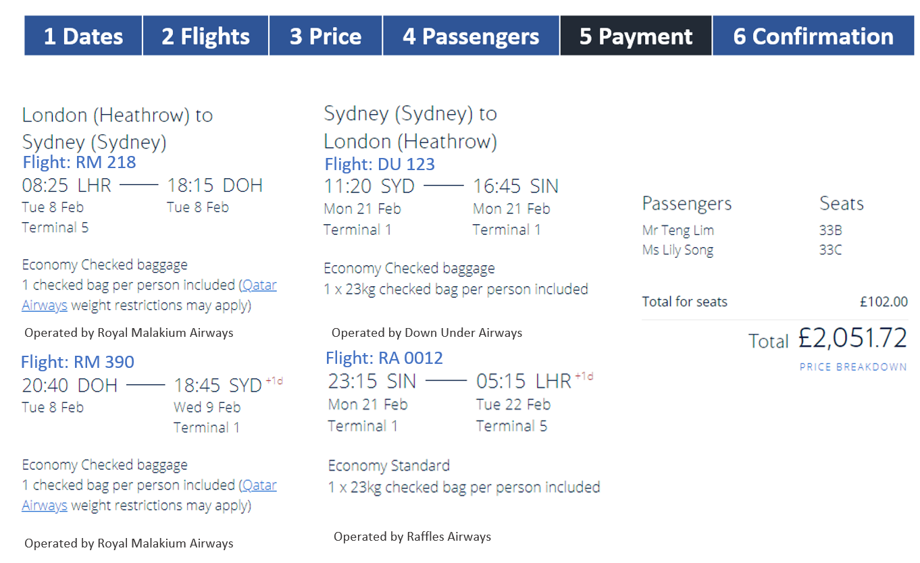
ANNEX B: CHECK-IN FLIGHT

